1995 Mariah Talari 190 ONLY $6,500

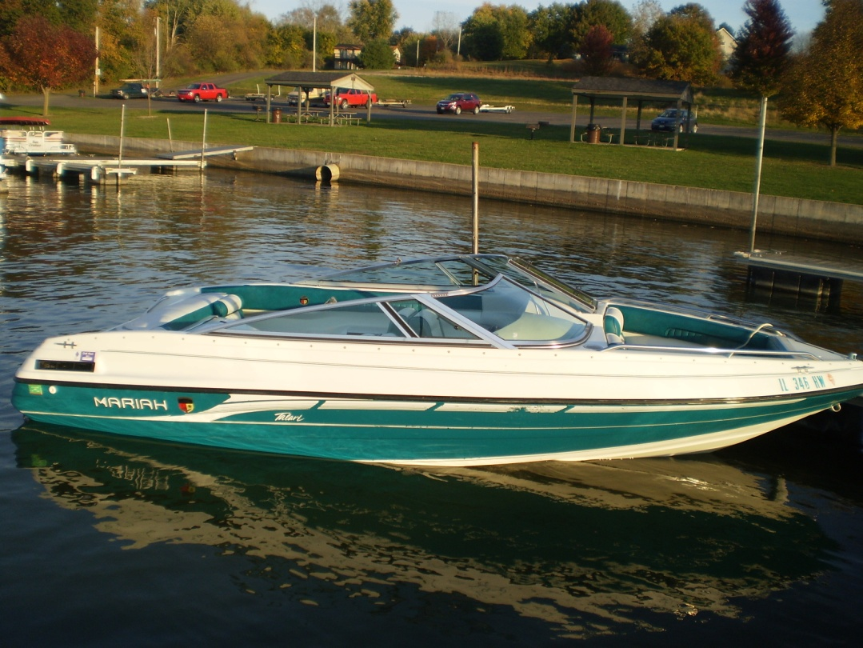
- Year: 1995
- Make: Mariah
- Model: Talari 190
- Length: 19 feet
- Location: Oak Run, IL
- Beam: 8 feet
- Trailer: Heritage single axle
- Drive: Single I/O
- Fuel Cap.: 20 gals.
- Fuel: Gasoline
- Engine: MerCruiserV-6
- HP: 190

Great boat. Impeccably maintained. Two matching covers for storage and travel. Fresh water lake use only. Heritage single axle trailer to match. All original upholstery/carpeting. Runs great. Bimini included. Open bow 19 ft. MerCruiser V-6 4.3LX engine.

Email danderson58@msn.com

